Design of a 5-DOF Robot Arm for Imitation Learning
Custom cycloidal reducers, a moteus CAN-FD drivetrain and a LeRobot software stack
Eric Oh · Mechanical Engineering, Northwestern University · Senior project, July–September 2026 (solo) · Written November 2026

Abstract
I designed, built and programmed a 400 mm reach, 5-degree-of-freedom robot arm whose purpose is to learn manipulation from human demonstrations. The design problem is dominated by one number: holding the arm straight out, the shoulder must resist about 5.2 N·m of static gravity torque, 17 times the 0.3 N·m continuous rating of the brushless motor I chose. I closed that gap with a custom 30:1 cycloidal reducer at the shoulder and two 15:1 cycloidals at the base and elbow, all 3D-printed, plus a gravity-feedforward controller. The shoulder clears its 1.2× torque requirement with a 1.48× margin using efficiency I measured on the bench (0.85). The arm runs on five mjbots moteus controllers on one CAN-FD bus and a LeRobot plugin stack I wrote (~4,000 lines of Python). An Action Chunking with Transformers (ACT) policy trained on 30 teleoperated demonstrations completed a pick-and-place task autonomously in 9 of 10 trials.
This paper walks through the design in the order I made the decisions: requirements, architecture, statics, actuator and reducer selection, cycloidal geometry, structure, electronics, controls, testing, and the failures I had to fix. Each section states the equation, the numbers, the alternatives I rejected and why.

1. Problem and requirements
Imitation learning needs a robot that is (1) affordable enough to build and break, (2) smooth enough to teleoperate precisely, so the demonstrations are good, and (3) well-sensed and repeatable, so a policy can learn from joint states and camera images. Commercial research arms meet (2) and (3) but cost thousands; hobby servo arms meet (1) but are weak, jerky and imprecise. My goal was to hit all three for about $1.4k with only a 3D printer.
Table 1. Requirements and the reason behind each.
Requirement | Value | Why
Degrees of freedom | 5 rotary joints | Position (3) + approach and roll of the gripper (2); enough for tabletop pick-and-place
Reach | 400 mm, shoulder axis to tool | Covers a tabletop workspace; sets every lever arm in the torque budget
Design payload | 0.2 kg at the tool | Blocks and small objects; documented stretch case 0.4 kg checked separately
Torque margin | ≥ 1.2× continuous over worst-case static holding torque, every joint | Covers printed-reducer friction variation, print quality and dynamic loads
Feedback | Absolute position at every joint (motor side) | Policy observations and closed-loop control
Bus | One power rail, one CAN-FD daisy chain | Simple wiring, synchronized reads and writes
Fabrication | 3D printer, heat-set inserts, set screws only | What I had: no machining, no epoxy, no pressed inserts
Software | LeRobot: teleop, recording, ACT training, inference | Standard tooling for imitation learning; datasets compatible with the community
Learning goal | Autonomous pick-and-place from teleop demos | The success criterion for the whole project

1.1 Ownership and timeline
This was a solo project: I wrote the requirements and torque budget, designed both reducers and the full SolidWorks assembly, built the wiring harness, and wrote the control software and learning pipeline. Dates below come from my repository history and build log.
Table 2. Project timeline.
Dates (2026) | Phase | Exit criterion / outcome
Jul 10 – Jul 23 | Requirements, architecture, torque budget workbook | Every joint row in the budget reads PASS
Jul 24 – Aug 4 | 30:1 and 15:1 cycloidal design, BOM, first prints, parts ordered | Printed 30:1 housing; raw motor torque test
Aug 5 – Aug 28 | Full-arm CAD: linkages, J4/J5 housings, gripper mount | Complete 5-DOF assembly in SolidWorks
Aug 20 – Sep 6 | 30:1 v2 (backlash fix), 15:1 build and fixes, reducer torque tests | Backlash visibly reduced; efficiency measured
Sep 7 – Sep 15 | Final prints, wiring, CAN-FD debugging, gripper, full assembly | All five controllers reliable on the bus
Sep 16 – Sep 21 | PID tuning, limits, keyboard then Xbox teleop, 30 demos, ACT training | 9/10 autonomous pick-and-place
Sep 20 – Sep 25 | URDF export and ROS 2 simulation | Model of the as-built arm

2. Architecture

2.1 Joint layout
The arm is J1 base yaw, J2 shoulder pitch, J3 elbow pitch, J4 forearm roll, J5 wrist roll. J4 sits just past the elbow (25 mm) and rolls the forearm about its own axis; J5 sits at the forearm tip, 125 mm further, and spins a gripper that hangs perpendicular to the forearm.
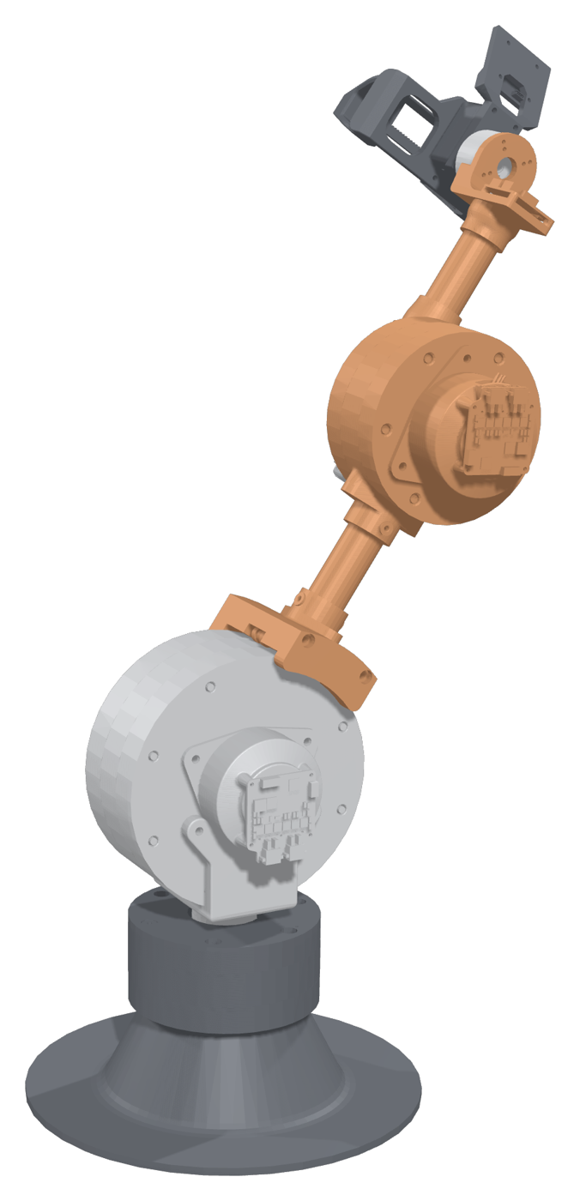
Figure 1. CAD render of the as-built arm: printed base, 30:1 shoulder gearbox, 15:1 elbow gearbox, carbon-fiber links, wrist actuators and camera gripper.

2.2 Why 5 DOF and not 6
I started with a 6-DOF design (forearm roll, wrist pitch, tool roll). The torque budget changed my mind: every gram at the wrist costs torque at the shoulder through the longest lever arm. The 3-axis wrist budgeted 0.35 kg at the forearm tip; moving the roll actuator back to the elbow and dropping one wrist axis brought that to 0.22 kg and cut the shoulder requirement by about 0.2 N·m and the elbow by about 0.15 N·m. Five joints still give full 3D position plus two orientation axes, which is what tabletop pick-and-place needs; the cost is that I cannot set position and full gripper orientation independently (Section 8.2).
Table 3. Architecture alternatives considered.
Option | Pros | Cons | Decision
6-DOF with 3-axis wrist | Full pose control; standard kinematics | +0.13 kg at the tip; higher J2/J3 torque; one more actuator and controller | Rejected
5-DOF, roll at the elbow (chosen) | Roll mass close to the elbow; lighter tip; one fewer joint | Constrained orientation; roll joint must pass wiring | Chosen
4-DOF SCARA-like | Simple, very stiff | No gripper tilt; poor for grasping from above at varied heights | Rejected

3. Statics: the torque budget
The torque budget sizes every actuator, so I built it first, as a spreadsheet, before choosing any motor. The worst case for gravity is the arm straight out horizontally, because every mass then sits at its maximum horizontal distance from the shoulder.

3.1 Free-body diagram and shoulder equation
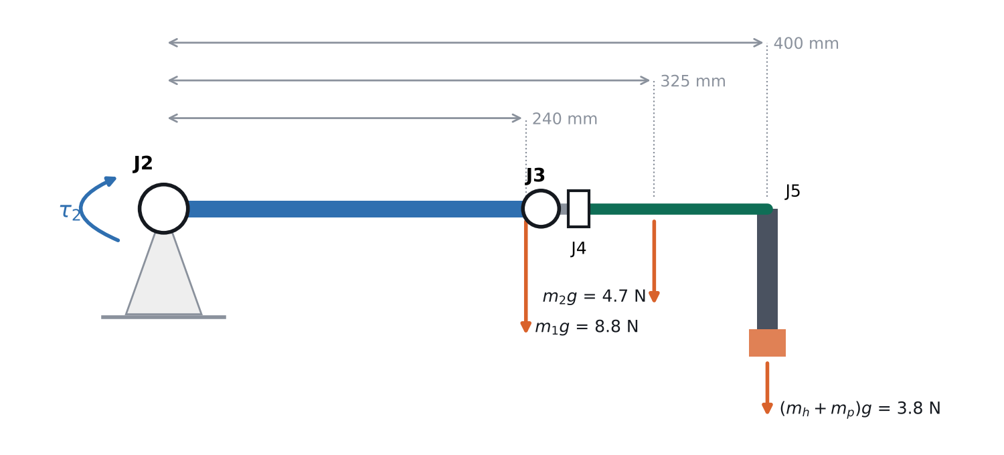
Figure 2. Free-body diagram about J2 with the arm horizontal. Masses use the as-built values measured for the gravity-feedforward model.
Summing moments about the J2 axis, each mass contributes its weight times its horizontal distance from the axis:
τ₂ = g · Σₖ mₖ · xₖ (1)
τ₂ = g · [ m₁c₁ + m₂(L₁ + c₂) + (mₕ + mₚ)(L₁ + L₂ + L₃) ] (2)
where m₁ = 0.90 kg is the upper segment including the 15:1 elbow gearbox (center of mass c₁ = 240 mm), m₂ = 0.478 kg is the forearm including the J4 and J5 actuators (c₂ = 75 mm past the elbow), and mₕ = 0.192 kg plus mₚ = 0.2 kg is the hand and payload, hanging below J5 at L₁ + L₂ + L₃ = 250 + 25 + 125 = 400 mm.
τ₂ = 9.81 × [0.90·0.240 + 0.478·0.325 + 0.392·0.400] = 9.81 × 0.528 = 5.18 N·m (3)
Table 4. Shoulder moment by component (arm horizontal, 0.2 kg payload).
Component | Mass (kg) | Lever arm (mm) | Torque about J2 (N·m) | Share
Upper segment incl. J3 gearbox | 0.900 | 240 | 2.12 | 41%
Forearm incl. J4 + J5 actuators | 0.478 | 325 | 1.52 | 29%
Hand (gripper + camera) | 0.192 | 400 | 0.75 | 15%
Payload | 0.200 | 400 | 0.78 | 15%
Total | 1.77 |  | 5.18 | 100%
The insight from this table: the elbow gearbox, not the payload, is the biggest load on the shoulder. That drove the decision to put a lighter 15:1 at the elbow and to keep the wrist light, and it shows up again in link sizing (Section 7.1).

3.2 The hanging hand: does J5 add lever arm?
The gripper hangs perpendicular to the forearm, so with the arm level its 50 mm (hand CG) and 80 mm (payload) drop is vertical and adds no moment about J2. It only matters when the forearm tilts by θ, which swings the hanging mass forward:
τ₂(θ) = g · [ A·cos θ + B·sin θ ], A = Σ mₖxₖ = 0.528 kg·m, B = mₕhₕ + mₚhₚ = 0.0256 kg·m (4)
τ₂,max = g·√(A² + B²) = 5.19 N·m at θ = atan(B/A) = 2.8° (5)
So the hang offset raises the worst case by only 0.1%. I include it anyway because it is the honest worst case, and it is the same √(A² + B²) term my link-sizing tool uses.

3.3 Elbow and wrist
τ₃ = g · [ m₂c₂ + (mₕ + mₚ)(L₂ + L₃) ] = 9.81 × [0.478·0.075 + 0.392·0.150] = 0.93 N·m (6)
J4 rolls the forearm about its own axis, so the 125 mm forearm length lies along J4's axis and produces no torque on it. J4 only sees the hand hanging off-axis, worst when the forearm is level and the hand is swung 90° sideways:
τ₄ = g · (mₕhₕ + mₚhₚ) · sin φ · cos θ_forearm ≤ 9.81 × 0.0256 = 0.25 N·m (7)
J5 spins the gripper about its own finger axis, so its gravity load is close to zero; it is sized for grasp disturbances (budgeted at 0.15 N·m). J1 base yaw has no gravity torque and is sized by friction and accelerating the arm's inertia (budgeted at 0.5 N·m).

3.4 Design-phase estimate vs. as-built
My spreadsheet used estimated masses before anything was built (0.89 kg J3 actuator, 0.12 kg each for J4 and J5, a 0.15 kg gripper) and gave τ₂ = 4.62 N·m. Measuring the built arm for gravity compensation raised it to 5.18 N·m, mostly because the wrist actuators with their controllers and housings weighed more than budgeted. The design still passed because I had sized for margin, and the lesson is to put contingency on distal masses specifically: each extra gram at 400 mm costs the shoulder the most.
Stretch payload: at 0.4 kg, τ₂ rises to 9.81 × 0.608 = 5.96 N·m; the 30:1 shoulder still clears it at 1.28×.

4. Actuator selection

4.1 Proximal joints: MJ5208 + moteus r4.11
For J1–J3 I chose the mjbots MJ5208 brushless motor (330 Kv, 1.7 N·m peak, about 0.3 N·m continuous with a heat spreader at 24 V) driven by moteus r4.11 controllers. The deciding factors were imitation-learning needs, not raw torque: field-oriented torque control, a kHz onboard position loop, smooth low-speed motion, and a single 5 Mbps CAN-FD bus that reads and writes every joint in one transaction.
Continuous vs. peak torque. Holding the arm out is a static, sustained load, so the motor must be sized on continuous (thermal) torque, not peak. Required motor torque at the worst-case shoulder pose:
τ_motor = τ₂ / (N·η) = 5.18 / (30 × 0.85) = 0.20 N·m (8)
That is 68% of the 0.3 N·m continuous figure. As a sanity check on current, the torque constant of a 330 Kv motor is roughly Kt ≈ 8.27/Kv ≈ 0.025 N·m/A, so holding the arm out draws roughly 0.20 / 0.025 ≈ 8 A of phase current: inside the r4.11's 12 A uncooled continuous rating, and the reason the heat spreaders are on the BOM.
Table 5. Actuator alternatives considered for J1–J3.
Option | Pros | Cons | Decision
Stepper + driver | Cheap, holding torque, simple | No torque sensing, open-loop step loss, poor backdrivability and smoothness for teleop | Rejected
Hobby bus servos (Feetech/Dynamixel) | Integrated, easy, LeRobot-native | Not enough torque at 400 mm (or very expensive); plastic gear backlash | Used only for the gripper
Quasi-direct drive (BLDC + ~6:1) | Backdrivable, transparent | Would need ~5× more motor torque at J2; heavy | Rejected for J2
BLDC + harmonic drive | Zero backlash, compact | $200+ per joint; not printable | Rejected (budget)
BLDC + printed planetary | Easy to print | Needs 2–3 stages for 30:1; each stage adds backlash | Rejected
BLDC + printed cycloidal (chosen) | High ratio in one stage, rolling contact, many teeth share load, printable | Design effort; tolerance-sensitive; eccentric bearing loads | Chosen

4.2 Wrist joints: GIM3505-8 + moteus-c1
J4 and J5 need only about 0.25 N·m, so a custom reducer would add mass and design time for no benefit. I used the SteadyWin GIM3505-8, an integrated 8:1 planetary gearmotor rated 0.67 N·m continuous (1.79 N·m peak), giving J4 a margin of about 0.67 / 0.25 ≈ 2.7×. I replaced its stock driver with a moteus-c1 so all five joints share the same firmware, bus and torque-control interface.
Integration problem: the c1's onboard encoder could not sit close enough to the motor's rotor magnet, and its screw holes landed on the motor body. Instead of redesigning the mount around the board, I ordered the GIM3505-8 with its own AS5047P encoder and wired it into the c1's AUX2 port, reconfiguring the controller to commutate from the external encoder (motor_position.sources.0.aux_number 2, cpr 16384, rotor_to_output_ratio 0.125). The motor's factory encoder is already correctly spaced from its magnet, which removed the standoff problem entirely.

5. Choosing the shoulder reduction ratio
Available continuous torque at a joint is the motor's continuous torque times the ratio times the reducer efficiency, and the output speed falls by the same ratio:
τ_avail = τ_cont · N · η ω_out = ω_motor / N (9)
margin = τ_avail / τ_required ≥ 1.2 (10)
Table 6. Shoulder (J2) reduction trade, using efficiencies I measured.
Option | Continuous τ at joint | Margin | Joint speed | Verdict
Direct drive | 0.30 N·m | 0.06× | 1440°/s | Fails
15:1 cycloidal (η = 0.92) | 0.3 × 15 × 0.92 = 4.14 N·m | 0.80× | 96°/s | Fails
30:1 cycloidal (η = 0.85) | 0.3 × 30 × 0.85 = 7.65 N·m | 1.48× | 48°/s | Chosen
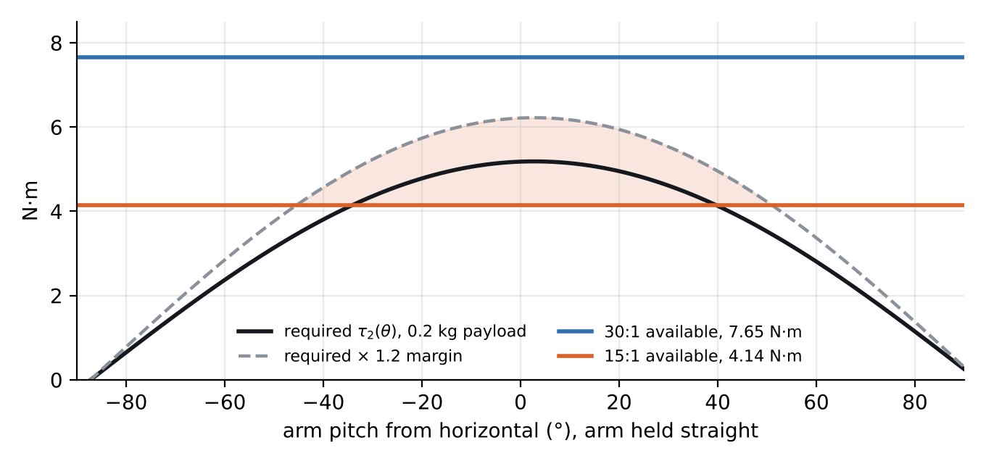
Figure 3. Shoulder holding torque vs. arm angle. The 15:1 fails (shaded) within about ±40–50° of horizontal once the 1.2× margin is applied; the 30:1 clears it at every angle.
Why not higher than 30:1? Speed and backdrivability. At 240 rpm motor speed under continuous load, 30:1 gives 48°/s at the shoulder, already the slowest joint; higher ratios make teleoperation sluggish, increase friction and make the joint harder to backdrive. 30:1 is the smallest ratio that passes, which is the right place to be.
A consequence I had to design around: the encoder is on the motor side. After a power cycle the controller knows the output angle only modulo one rotor turn, which is 360°/N = 12° at 30:1 (24° at 15:1). The software therefore re-homes on every connect: I place the arm within ±6° of its reference pose and the controller snaps to the consistent output position (Section 10).

6. Cycloidal reducer design

6.1 How it works
An eccentric cam on the motor shaft makes a lobed disc orbit inside a ring of Nₚ fixed rollers. The disc has one fewer lobe than there are rollers, so each full input turn advances the disc backward by one lobe. Pins on the output flange ride in oversized holes in the disc and pick up its slow rotation while ignoring its orbit.
i = Nₚ / (Nₚ − N_lobes) = Nₚ − 1 (N_lobes = Nₚ − 1) (11)
With 31 rollers the ratio is 30:1; with 16 it is 15:1. The output turns opposite to the input. Two discs mounted 180° out of phase cancel the eccentric imbalance and share the load.

6.2 Disc profile
The disc profile is the equidistant offset of an epitrochoid, the path a ring-roller center traces relative to the disc. With R the ring pin-circle radius, R_r the roller radius, e the eccentricity and N the number of rollers, parameter t from 0 to 2π:
ψ(t) = atan[ sin((1 − N)t) / ( R/(eN) − cos((1 − N)t) ) ] (12)
x(t) = R cos t − R_r cos(t + ψ) − e cos(Nt) (13)
y(t) = −R sin t + R_r sin(t + ψ) + e sin(Nt) (14)
These go straight into a SolidWorks equation-driven curve, driven by global variables (R_ROLL, D_SUN, NUM_ROLL, RHO, D_SHAFT, D_OUTPUT, NUM_OUT, R_OUT_ROLL) so one table regenerates the whole gearbox.
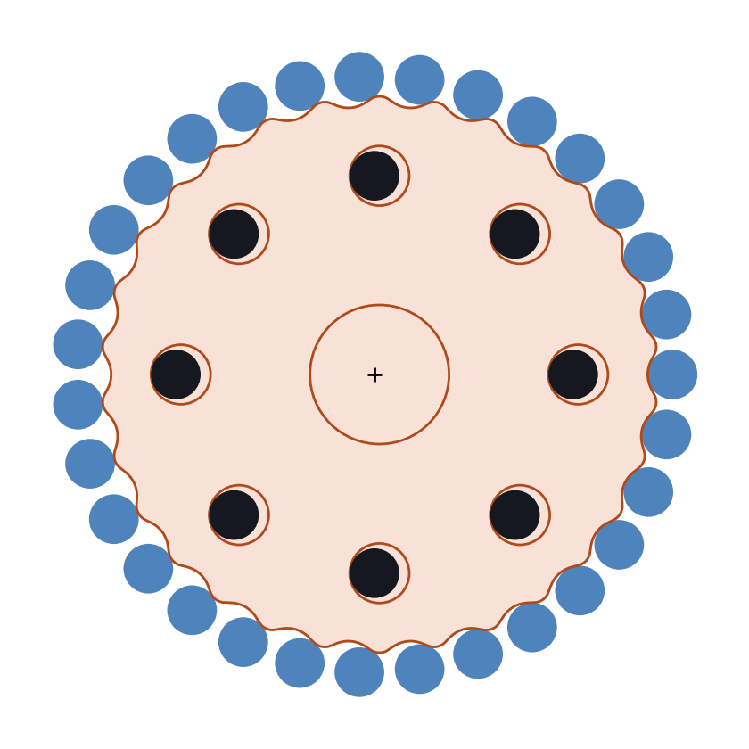
Figure 4. 30:1 disc (orange) with 31 ring rollers (blue) and 8 output rollers in their oversized holes, from the same equations.

6.3 Design checks
Tooth-shape coefficient. K₁ = eN/R sets how deep and how pointed the lobes are; roughly 0.5–0.8 is the usable range. Too low and the teeth are shallow; near 1 the profile develops sharp points.
K₁ = e·N / R = 1 × 31 / 60 = 0.52 (15)
Undercut. Offsetting the epitrochoid inward by R_r fails (the profile loops on itself) wherever the curve's radius of curvature ρ is smaller than R_r. I traced the profile numerically: the tightest lobe curvature is ρ_min = 8.1 mm against R_r = 5 mm, so there is no undercut and about 3 mm of margin.
ρ_min > R_r → 8.1 mm > 5 mm (16)
Output holes. Each output roller orbits with the disc at radius e, so the hole must be larger than the roller by 2e:
D_hole = 2r_out + 2e (+ 2·clearance) = 10 + 2 = 12 mm (17)
Table 7. 30:1 reducer parameters and checks.
Parameter / check | Value | Comment
Ring pin circle D_SUN / rollers | 120 mm / 31 × Ø10 mm | Roller centers 12.2 mm apart, 2.2 mm gap
Eccentricity e | 1.0 mm | Tooth depth 2e = 2 mm (profile radius 54–56 mm)
K₁ | 0.52 | In range, shallow end
Undercut margin | ρ_min − R_r = 3.1 mm | No undercut
Output pins | 8 × Ø10 mm on Ø80 mm | Holes Ø12 mm
Wall: hole to tooth root | 54 − 46 = 8 mm | Thinnest wall; 20 × nozzle width
Wall: between holes | 18.6 mm | Ample
Discs | 2 × 8 mm, 180° apart | Cancels imbalance
Cam bearings | 15 × 28 × 7 mm, one per disc + two support bearings | Shaft supported on both sides, not cantilevered
Assembly mass | ≈ 1.32 kg incl. motor and controller
The 15:1 units use 16 rollers on an 80 mm pin circle with e = 1 mm, which gives K₁ = 0.40, shallower than ideal. It works because the elbow and base carry far less torque, but it is the first thing I would change (Section 12).

6.4 Loads
The input torque is reacted through a lever only e long, so the eccentric bearings see large forces. As an order-of-magnitude estimate at full shoulder torque:
F_cam ≈ T_out / (i · e) = 7.65 / (30 × 0.001) ≈ 255 N (≈ 130 N per disc) (18)
That is small for a 15 × 28 mm ball bearing, which is rated in the kilonewton range, but large for printed plastic, which is why every load path ends in a bearing, a steel pin or a heat-set insert rather than a printed bore.

6.5 Backlash and tolerance
Backlash in a cycloidal drive comes from clearances, and each clearance acts through a lever arm. A profile clearance δ between disc and rollers acts through roughly eN; an output-hole clearance acts at the output pin radius:
Δθ_profile ≈ δ / (e·N) = 0.1 / 31 = 0.0032 rad ≈ 0.18° (19)
Δθ_output ≈ δ / r_out = 0.1 / 40 = 0.0025 rad ≈ 0.14° (20)
Three things follow. Print clearance is the biggest lever on backlash. A larger eccentricity reduces it in proportion. And input-side play (the hex shaft) is divided by 30 and hardly matters. Printing turns these into concrete fits: I found a +0.1 mm outward profile offset on the disc and nominal 5 mm press-fit holes for the roller pins worked best on my printer (Section 11).

7. Links and structure

7.1 Link length split
With 400 mm total reach fixed, how should it split between upper arm (L₁) and forearm? J2's load is dominated by the elbow gearbox sitting at L₁, so a shorter L₁ helps the shoulder, while a longer forearm loads the elbow. I wrote a sweep that recomputes both margins for every split:
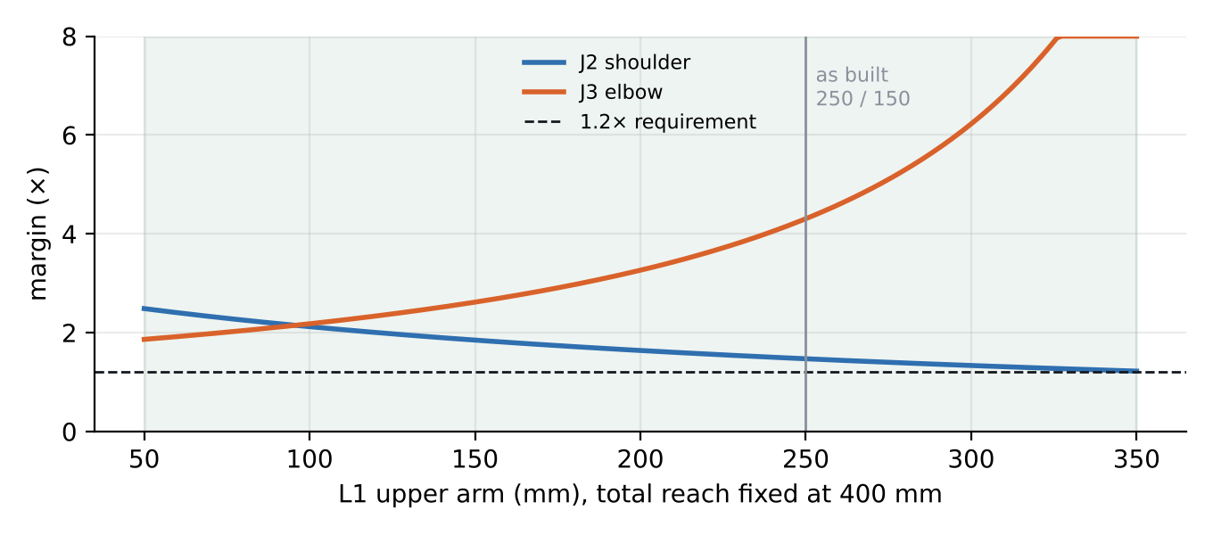
Figure 5. J2 and J3 margins vs. L₁ at 400 mm reach. Both pass for L₁ from about 130 to 350 mm (shaded); the as-built 250/150 split gives J2 1.47×.
Both joints pass across a wide band. An even 200/200 split would have raised J2's margin to about 1.64× and removed the 100 mm unreachable zone near the shoulder (inner radius = |L₁ − L_forearm|). I chose 250/150 because it put the elbow gearbox where it packaged cleanly. It passes, but the sweep shows 200/200 is better on both workspace and torque, and I would use it next time.

7.2 Tube strength
Links are 25 × 23 mm carbon-fiber tubes clamped in printed fittings. The tube itself is far from its limit; checking bending at the shoulder end with the full 5.18 N·m:
Z = π(D⁴ − d⁴) / (32D) = π(25⁴ − 23⁴) / (32 × 25) = 435 mm³ (21)
σ = M / Z = 5180 N·mm / 435 mm³ ≈ 12 MPa (22)
That is a few percent of carbon fiber's strength, so the weak points are the printed clamps and heat-set inserts, not the tube. That is why the clamps are bolted, not glued, with M2.5 and M5 inserts, and why the design rule was that every load path ends in a bearing, an insert or a printed feature in compression.

7.3 Manufacturing
- All housings, discs, cams and clamps printed; 15 M5 heat-set inserts per 15:1 reducer, M2.5 inserts in couplers.
- Steel 5 mm pins with 5 × 10 × 4 mm ball bearings as rollers, so every tooth contact is rolling, not plastic sliding.
- Hex input shafts cut to length with a rotary tool; part identifiers modeled into the CAD so the many near-identical printed parts assembled correctly.
- Tubes cut to length; clamp fittings let me change link lengths after testing without reprinting everything.

8. Kinematics and workspace

8.1 Reach
J2 and J3 form a planar two-link arm with links L₁ = 250 mm and L_f = L₂ + L₃ = 150 mm (J4 rolls about the forearm axis and does not change its length). The wrist can reach an annulus around the shoulder, which J1 sweeps about the vertical axis:
|L₁ − L_f| ≤ r_wrist ≤ L₁ + L_f → 100 mm ≤ r ≤ 400 mm (23)

8.2 The 5-DOF orientation constraint
Because the gripper hangs perpendicular to the forearm, it points straight down only when the forearm is level. That leaves one free variable, the shoulder angle θ₂, so top-down grasp positions lie on an arc of radius L₁. With the shoulder axis about 212 mm above the table and the tool 80 mm below the wrist, the tool reaches the table with a vertical gripper at one radius:
z_tool = h + L₁ sin θ₂ − h_p = 0 → sin θ₂ = (80 − 212)/250 → θ₂ = −32°
r = L₁ cos θ₂ + L_f = 212 + 150 ≈ 362 mm (24)
Everywhere else the gripper tilts, which is the trade-off I accepted for removing a wrist axis. An ACT policy learns to grasp with the tilt, so this did not block the task, but it is the first thing an interviewer may probe about 5-DOF arms.

9. Electronics
- Bus: three moteus r4.11 (J1–J3) and two moteus-c1 (J4–J5) daisy-chained on one 5 Mbps CAN-FD bus to a single fdcanusb adapter; all run the same firmware and connectors, so the host sees one homogeneous bus.
- Power: one 24 V rail daisy-chained with custom soldered XT30 Y-splitters.
- Wrist wiring: GIM3505-8 phase leads extended with soldered, heat-shrunk joints; encoder leads re-crimped to JST-GH for the c1's AUX2 port.
- Gripper: Feetech STS3215 serial bus servo on a Waveshare driver board; wrist camera (Arducam UVC) and a RealSense D435 scene camera on USB.
- Fail-safe settings on every controller: servo.default_timeout_mode 12 (hold damped, not limp, if the host stops) and servopos.position_min/max limits flashed in the calibrated frame.

10. Controls and software

10.1 Control split
Each moteus runs commutation, current control and a PD position loop at kHz rates; the host runs at 30 Hz and sends, per joint, a target position, a target velocity, a feedforward torque, torque/velocity/acceleration limits and a watchdog timeout, then reads all states back in the same CAN-FD round trip. Python cannot close a kHz loop, so the host supplies targets and physics, and the controllers do the fast work.
τ_cmd = k_p (θ_goal − θ) + k_d (ω_goal − ω) + τ_ff (25)

10.2 Gains in output units
With the gear ratio flashed on the controller, the loop works in output revolutions. The stock gain k_p = 4 N·m/rev is sized for direct drive, so a 2° error produced only 4 × 2/360 ≈ 0.02 N·m, and the arm hung limp. I retuned each joint, starting near k_p = 150 N·m/rev (≈ 0.4 N·m per degree), tip to base with the arm supported, raising k_p until a small step rang for one or two cycles and backing off a third. Torque chattering rail to rail at every k_p turned out to be k_d amplifying a noisy velocity estimate; light wrist joints need k_d near 0.05, heavy shoulder joints around 4.

10.3 Gravity feedforward
Without an integrator, a joint settles where k_p·error balances gravity, so it always sags toward the ground by τ_g / k_p. I avoided an integrator (it lags and winds up as the load changes with pose) and instead compute gravity torque every tick from the measured pose, using Equations 2, 4 and 7, and send it as τ_ff. I validated the model by holding poses: the torque each controller reports while holding still is the gravity torque, so measured minus model is the model error, and I tuned the masses until the residual was small before raising the feedforward from 70% to 100%.

10.4 Smooth motion and safety
Teleop targets arrive as a 30 Hz staircase. Sending each step with zero velocity makes the controller plan a stop 30 times a second. The bus estimates how fast each goal is moving and sends that as ω_goal, so the controller extrapolates between ticks and the motion becomes a ramp. Safety is layered: a 10° leash between teleop target and measured pose, calibrated soft limits, a 2° per-tick step cap, per-joint torque/velocity/acceleration ceilings, a 0.25 s controller watchdog with a keepalive thread, stale-reading detection, fault checks after every write, on-controller position limits and an e-stop. The arm has no brakes, so no single failure is allowed to drop it.

10.5 LeRobot integration
I wrote three plugin packages that LeRobot discovers automatically: the follower robot (with a custom motor bus for moteus, an asyncio-to-synchronous bridge thread, calibration, homing and gravity feedforward), a keyboard teleoperator and an Xbox gamepad teleoperator. Stock LeRobot commands for calibration, teleoperation, recording and training work unchanged. The full software guide is a separate document.

11. Testing and results

11.1 Reducer efficiency test
I commanded a fixed motor torque, measured the output force on a scale at a known radius, and compared output torque F·r with the ideal N·τ_in. I tested the bare motor first as a baseline, and it read 12.5% above command, meaning the controller's torque estimate under-reports at this operating point. I divided every reducer result by that factor:
η = (F · r) / (N · τ_in · k), k = 1.125 (bare-motor baseline) (26)
Table 8. Static output torque tests.
Unit | τ_in (N·m) | F (N) | r (m) | F·r (N·m) | Ideal (N·m) | Raw ratio | Corrected η
Bare motor | 0.20 | 3.0 | 0.075 | 0.225 | 0.20 | 1.13 | (baseline)
15:1 | 0.20 | 33.5 | 0.100 | 3.35 | 3.00 | 1.12 | 0.99
15:1 | 0.10 | 15.5 | 0.100 | 1.55 | 1.50 | 1.03 | 0.92
30:1 | 0.10 | 28.7 | 0.100 | 2.87 | 3.00 | 0.96 | 0.85
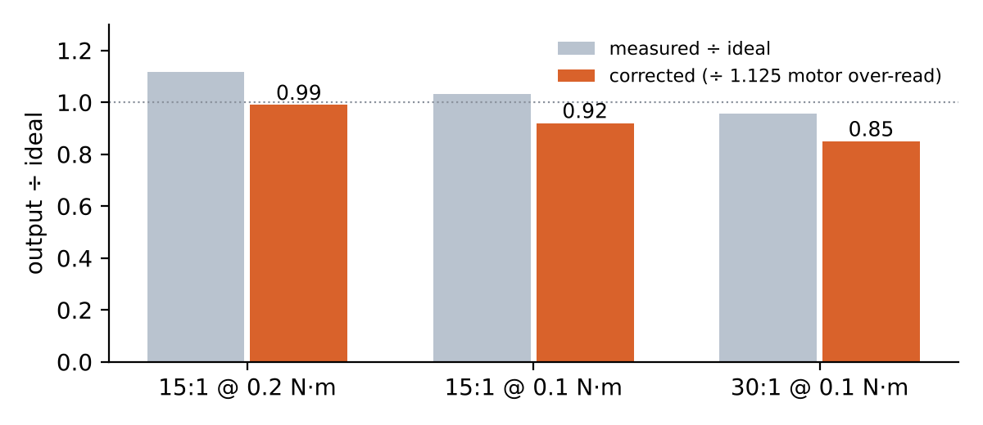
Figure 6. Measured output ÷ ideal, raw and corrected for the motor's 12.5% over-read.
Without the baseline, the 15:1 would have looked more than 100% efficient, which is impossible; calibrating the instrument first is the most important thing this test taught me. Limitations: each value is a single static pull at low input torque (0.1–0.2 N·m), so it characterizes gearbox losses but does not yet confirm efficiency at the 5 N·m holding load.

11.2 Learning result
Using the Xbox teleoperator, I recorded 30 demonstrations of picking a block and placing it in a bin (two cameras at 640 × 480, 30 fps, joint state and action at 30 Hz) and trained an ACT policy (batch size 16, 75,000 steps). Running autonomously on the real arm with all safety layers active, it succeeded in 9 of 10 trials (90%). Ten trials is a preliminary sample, which I state whenever I quote the number.

12. Challenges and failures
Table 9. Problems I hit, their root causes and the fixes.
Problem | Root cause | Fix | Evidence
30:1 v1 backlash | Loose-fit roller-pin holes let pins shift under load; disc-to-roller clearance | Press-fit 5 mm holes; disc profile +0.1 mm | Visibly less play (judged by hand)
15:1 input binding | Camshaft rubbing the output flange; tight shoulder bolts | Corrected fits in CAD, reprinted, eased bolt preload | Turns freely
Wrist controller would not mount | c1 board could not reach the rotor magnet; screw holes on motor body | Use the motor's own AS5047P via AUX2 | Calibrated and running
Oblong insert hole in coupler | Vertical small hole printing poorly | Printer tuning + smaller CAD hole | Inserts seat properly
J1–J2 connector interference | Clash with the J1 gearbox interface | Redesigned connector | Assembled
Intermittent CAN-FD | Bad crimps and solder joints in the custom harness | Found with moteus_tool -s while flexing wires; re-crimped | Reliable through all 5 nodes
Limp arm | Stock gains sized for direct drive | Retuned in output units; gravity feedforward | Every joint tracks
Stale positions every Nth read | Async event loop pumped per call; serial buffer filled between ticks | Run the loop continuously on its own thread | Fresh state every tick
Gripper driven into its stop | Hand-entered calibration range wider than the stroke | Self-calibrating sweep at 15% torque; 40% cap; range check on connect | No recurrence

13. Lessons and what I would change

13.1 Lessons
- Size on the distal masses. The elbow gearbox and wrist set the shoulder torque; budget contingency there first.
- Calibrate the instrument first. The 12.5% motor over-read would otherwise have hidden reducer losses.
- On a printed part, tolerance is a design parameter. Offsets and fits must be tuned to the printer, not taken from nominal CAD.
- Software limits are cheaper than reprints. Every hardware scare became a permanent safety layer.

13.2 If I did it again
- Output-side absolute encoders on J1–J3, to remove manual homing after power cycles and measure backlash and wind-up directly.
- 200/200 link split, for a higher shoulder margin (≈1.64×) and no unreachable zone near the base.
- Raise the 15:1 eccentricity to ~1.25 mm (K₁ 0.40 → 0.50), cutting profile backlash about 20% and making the teeth more tolerant of print error.
- Quantitative backlash and efficiency testing at holding loads (2–5 N·m) with a dial indicator, instead of judging play by hand at 0.1–0.2 N·m.
- Evaluate the policy on 50+ trials with varied object placement, and use the URDF for simulation to iterate faster.

14. Deep-dive questions and answers
Q: Walk me through how you sized the shoulder.
A: Worst case is the arm straight out. I summed weight × horizontal distance for each mass (Eq. 2): 5.18 N·m with a 0.2 kg payload. The motor gives 0.3 N·m continuous, so I needed N·η ≥ 5.18 × 1.2 / 0.3 ≈ 21. With a measured η of 0.85, 30:1 gives 7.65 N·m and a 1.48× margin; 15:1 gives only 0.80×.
Q: Why size on continuous rather than peak torque?
A: Holding the arm out is a static, indefinite load, so the limit is heat in the windings, not peak current. Peak (1.7 N·m) only matters for short accelerations. At the worst pose the motor needs 0.20 N·m, about 8 A, within the controller's 12 A continuous rating.
Q: Why a cycloidal and not a planetary or harmonic drive?
A: One stage reaches 30:1, many lobes share the load, the contacts roll on steel pins and bearings, and it is printable. A printed planetary would need two or three stages, each adding backlash; a harmonic drive is zero-backlash but costs hundreds of dollars per joint and cannot be printed.
Q: Derive the cycloidal ratio.
A: The disc has Nₚ − 1 lobes inside Nₚ rollers. Each input turn, the disc rolls around the ring and lags by one lobe, so it rotates 1/(Nₚ − 1) of a turn backward per input turn: i = Nₚ − 1, reversed.
Q: How did you check the disc profile?
A: K₁ = eN/R = 0.52 is in the usable 0.5–0.8 range; I traced the profile numerically and the minimum radius of curvature, 8.1 mm, exceeds the 5 mm roller radius, so there is no undercut; the walls around the output holes are at least 8 mm.
Q: Where does backlash come from and how did you reduce it?
A: Clearances acting through lever arms: Δθ ≈ δ/(eN) at the profile and δ/r_out at the output pins. A 0.1 mm clearance is about 0.18° + 0.14°. My v1 backlash came mostly from loose pin holes letting pins shift; press fits and a +0.1 mm profile offset fixed it.
Q: How did you measure efficiency, and what is wrong with the test?
A: Fixed motor torque, scale force at a known radius, F·r over N·τ_in, corrected by a 1.125 bare-motor baseline. The limits: single static pulls at low torque, so it characterizes losses but not efficiency at the 5 N·m holding load.
Q: What would happen with a heavier gripper?
A: Every extra kilogram at 400 mm adds about 3.9 N·m at the shoulder. The current margin of 7.65 − 5.18 = 2.47 N·m allows about 0.6 kg more at the tip before hitting 1.0×, or about 0.3 kg more before dropping below 1.2×.
Q: Why only 5 DOF?
A: Wrist mass costs shoulder torque through the longest lever arm. Moving roll to the elbow and dropping one wrist axis took the tip from 0.35 to 0.22 kg. The trade-off is orientation: a vertical grasp is only possible on one radius on the table, so other grasps are tilted, which the learned policy handles.
Q: Why gravity feedforward instead of integral action?
A: Gravity load changes with pose; an integrator lags it and winds up, then overshoots. The feedforward computes the load directly from the measured pose each tick, so the PD loop only corrects a small residual, and I can validate it against the torque the controllers report.
Q: What happens if the computer crashes?
A: Commands stop, the 0.25 s watchdog expires and the controllers enter a damped zero-velocity mode instead of going limp. On-controller position limits still apply. During recording, a keepalive thread re-sends the held goal so a slow host never trips the watchdog.
Q: What was the hardest problem?
A: Two: the shoulder torque (solved with the 30:1 cycloidal and feedforward), and the async moteus driver returning the previous tick's position, which I traced to the event loop only being pumped during calls; running it continuously on its own thread fixed it.

Appendix: key numbers
Quantity | Value
Reach / links | 400 mm; L₁ 250, J3→J4 25, J4→J5 125 mm
Shoulder torque, arm level, 0.2 kg | 5.18 N·m (5.19 with hang offset); 5.96 at 0.4 kg
Elbow torque / J4 torque | 0.93 N·m / 0.25 N·m
MJ5208 | 330 Kv, 1.7 N·m peak, ~0.3 N·m continuous with heat spreader
Shoulder available / margin | 0.3 × 30 × 0.85 = 7.65 N·m / 1.48×
Joint speeds at continuous | 48°/s (30:1), 96°/s (15:1)
30:1 geometry | 31 rollers Ø10 on Ø120, e = 1 mm, K₁ 0.52, 8 output pins on Ø80, holes Ø12
15:1 geometry | 16 rollers Ø10 on Ø80, e = 1 mm, K₁ 0.40, 6 output pins on Ø40
Measured efficiency | 15:1 0.99 / 0.92; 30:1 0.85 (baseline-corrected)
Rotor-turn ambiguity | 12° (30:1), 24° (15:1); homing window ±6° at the shoulder
Control | 30 Hz host, kHz onboard; k_p ≈ 150 N·m/rev start; 0.25 s watchdog
Learning | 30 demos, ACT, batch 16, 75k steps, 9/10 success
Budget | ≈ $1,390 BOM

